**Map Struct Implementation**

**Gradle Dependency**

Add below line of code to your build.gradle file to add gradle dependency.

**buildscript** {

**repositories** {

mavenLocal()

}

**dependencies**{

classpath "net.ltgt.gradle:gradle-apt-plugin:0.5"

}

}

**apply** plugin: 'net.ltgt.apt'

**sourceCompatibility** = 1.8

//mapstruct dependancy

compile("org.mapstruct:mapstruct:1.0.0.Final")

apt 'org.mapstruct:mapstruct-processor:1.0.0.Final'

**Configuration with eclipse**

1. Click on window->preferences tab.
2. Click on Arguments inside Gradle

You will see below screen-

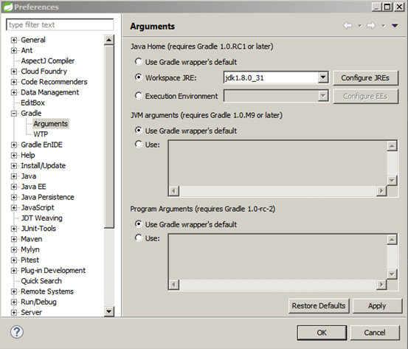

1. Select Workspace JRE and set there JDK instead of JRE. Then click Apply and OK.
2. Right click on project and then click on “Properties” option where u can find “Annotation processing “inside “Java Compiler” option.

You will get below screen

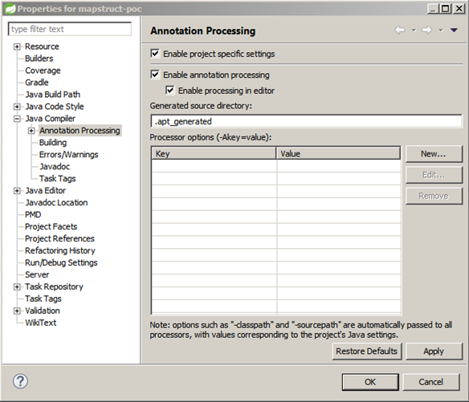

1. Select all checkbox and then Apply and OK.

Now all is done.

**Sample “build.gradle” with Map Struct Implementation**

**buildscript** {

**repositories** {

mavenLocal()

}

**dependencies**{

classpath "net.ltgt.gradle:gradle-apt-plugin:0.5"

}

}

**apply** plugin: 'java'

**apply** plugin: 'eclipse'

**apply** plugin: 'net.ltgt.apt'

**sourceCompatibility** = 1.8

**version** = '1.0'

jar {

**manifest** {

attributes 'Implementation-Title': 'Gradle Quickstart', 'Implementation-Version': **version**

}

}

**repositories** {

mavenCentral()

}

**dependencies** {

compile **group**: 'commons-collections', **name**: 'commons-collections', **version**: '3.2'

testCompile **group**: 'junit', **name**: 'junit', **version**: '4.+'

//mapstruct dependancy

compile("org.mapstruct:mapstruct:1.0.0.Final")

apt 'org.mapstruct:mapstruct-processor:1.0.0.Final'

}

**test** {

systemProperties 'property': 'value'

}

uploadArchives {

**repositories** {

flatDir {

dirs 'repos'

}

}

}